**MATERIAL BALANCES FOR AMBROXOL**

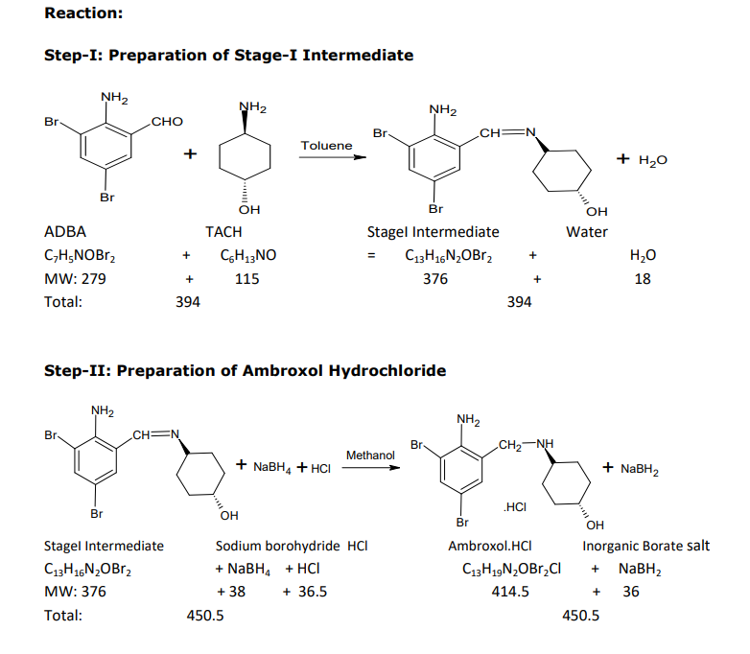

Reaction taking place in 2 stages as shown above.

Yield of step-1 reaction is 90.16% (in some plant) for calculation we will roughly use 90%.

For production of 3.44kmol/day of intermediate production with 90% actual yield we need

3.82kmol/day of ADBA i.e.1066.4kg/day of ADBA required.

We need the 3.82 Kmol/day of TACH also but in general industrial practices it is taken in some extra amount typically 1.5 times ADBA so we need 658.95kg/day of TACH.

Amount of Water generated is 3.44kmol/day i.e. 61.92litres/day.

Yield of step-2 reaction is 71.17% (in some plant) for calculations we will roughly use 70%.

We need to produce 1000kg/day of ambroxol i.e. 2.41kmol/day with 70% actual yield we need 3.44kmol/day of intermediate.

In industrial practices NABH4 taken 3.5-4 times stage intermediate we are taking 3.75 times so for our plant production we need 12.9kmol/day of NaBH4 i.e. 490.2kg/day required.

In industrial practices HCl taken roughly same quantity as stage intermediate, we need 125.56kg/day of HCl for our plant.

Amount of NaBH2 produced is 12.9kmol/day i.e. 464.4kg/day.